**Assembler Project**

Project in CAO1, 3rd Semester. Counter project is made for counting, detecting movement of people passing through certain way. Project is made using Adeept Mega 2560 Arduino microcontroller.

**Problem statement**

What can be done to detect movement of people passing through certain way?

* LightOn - state where LED is on.
* LightOff - state where LED is off.

**Design**

The purpose of this project is to detect movement of people passing through certain way. . When there is movement in front of PIR Movement sensor program goes to LightOn state, after 3 seconds it goes back to LightOff state. Led will be output.

When there is movement in front of PIR Movement sensor program goes to LightOn state, after 3 seconds it goes back to LightOff state.

**Testing**

PIR Movement sensor test and LED:

Purpose for the test is to test PIR Movement sensor and LED.

**Excepted result:**

When there is movement in front of PIR Movement sensor the LED lights up.

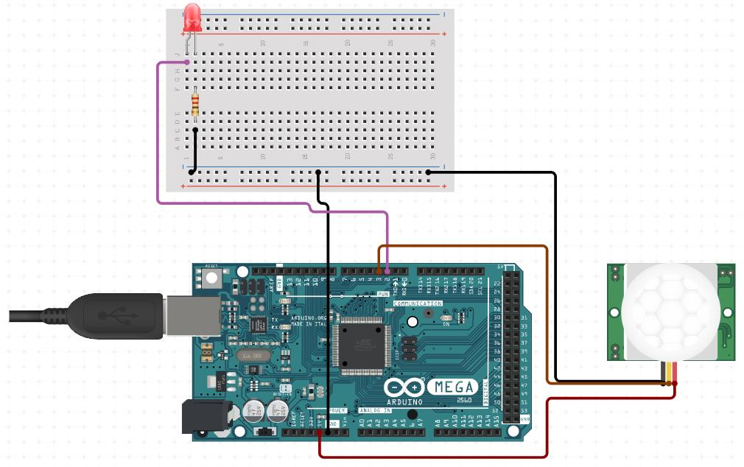

**Code:**

LDI R21, (1 << PE4);set the register

OUT DDRE,R21 ;set port E to output

//LDI R22,0xFF

//OUT DDRB,R22 ;set portB to output

hel:

IN R20,PINE;set the register

ANDI R20, (1 << PE5);do and

CPI R20,0 ;compare R20 and 0

BRNE on ;if not,go to on

LDI R17,0

OUT PORTE,R17

JMP hel

on:

LDI R17, (1 << PE4);set the register

OUT PORTE,R17

JMP hel

Result:

Result as expected. When there is movement LED light up

**Project diagram**

Things used:

1. 6 Wires
2. 1 PIR Movement sensor
3. 1 Adeept mega 2560 microcontroller board
4. 1 Breadboard
5. 1 LEDs
6. 1 220Ω resistors

PIR Movement sensor is connected to 3 wires, one is connected to ground to microcontroller, one is connected to 5V power to microcontroller and the other wire is connected to pin 3. Pin 2 from microcontroller is connected to breadboard where is connection to the LEDs. The resistor is connected to negative leg of LEDs.

